Pg-356 has theory related to it

TIMER IS RUNNING

Input capture – gives time between active input events. **Examples of uses of the IC function include counting events and timing events.**

Output capture – generates interrupts on timer overflows or timer compare events and toggles pin. The output compare generates an interrupt when the free-running counter (TCNT) is equal to a 16 bit value stored in one of the Timer Output Compare Register. In addition to generating the interrupt, the state of the associated output pin can be controlled to go low, high or toggle. **Examples of uses of the OC function include generating a wave form with desired frequency and duty cycle or making precise timing applications.**

TIMER may NOT RUNNING..

Pulse accumulator – counts input events such as motor revolutions and then report by interrupt on overflow or compare success.

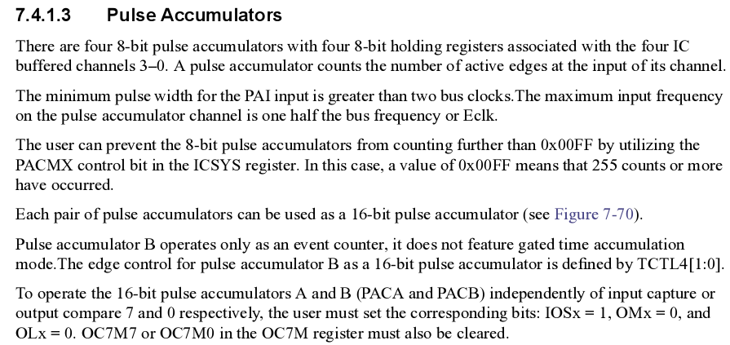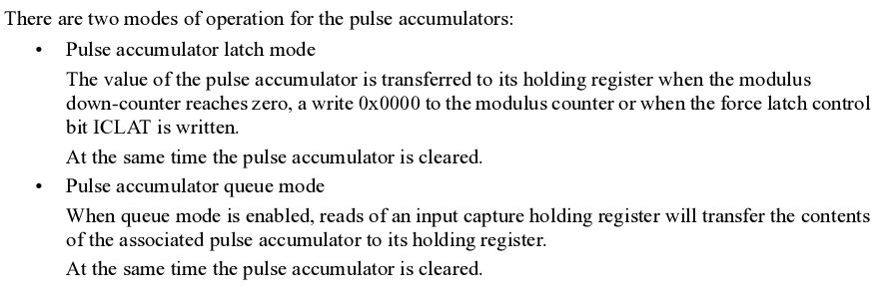

Pg-359

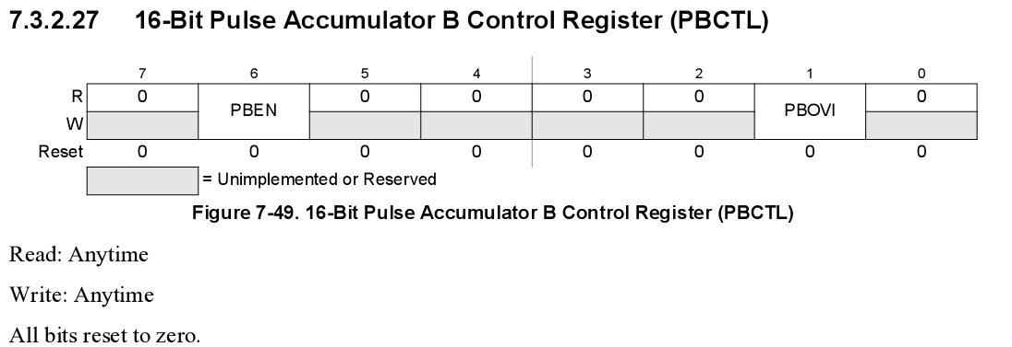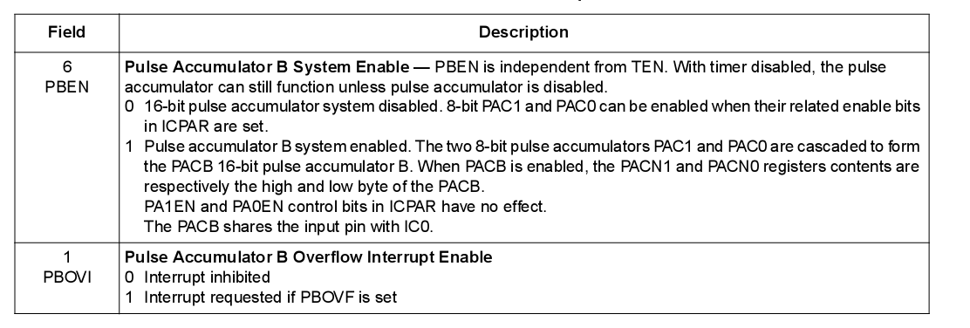

Pg-345

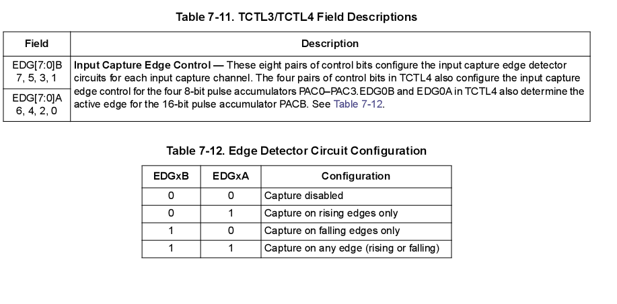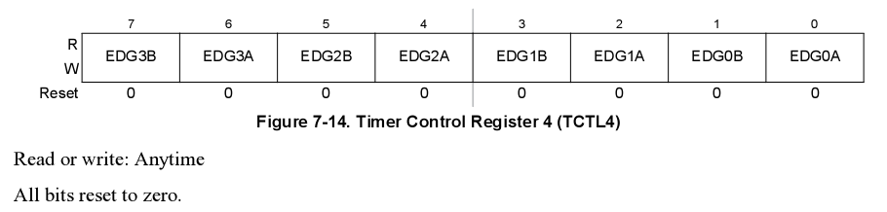pg-325

